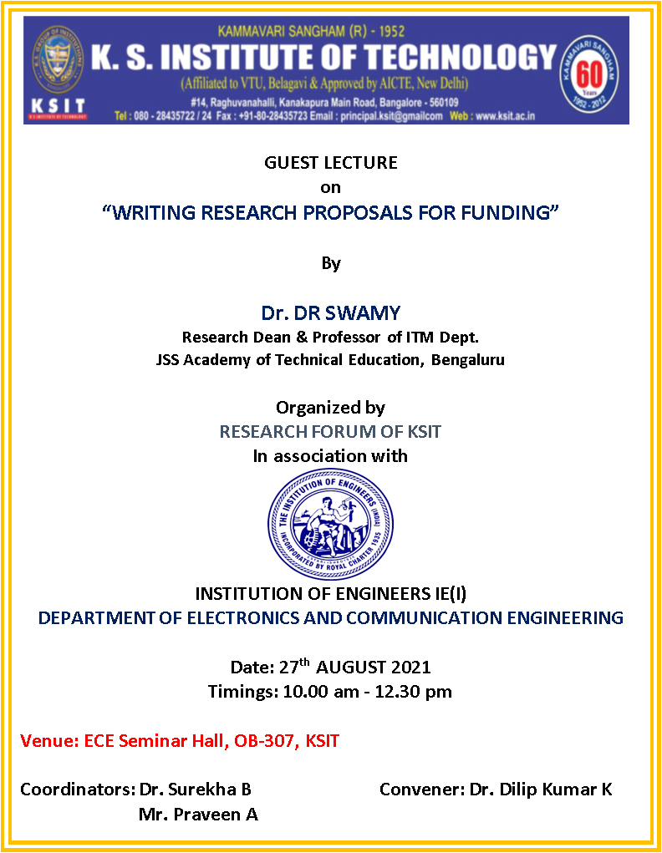

CONTENTS

GUEST LECTURE on“Writing research Proposals for funding” byDr.Swamy, Professor, Department of IEMJSS Academy of Technical Education, Bangalorewas arranged by KSIT Research Forum and IE(I), dept. of ECE, for faculty on 27th August 2021 at 10amin ECE Seminar Hall, Old Building, KSIT.
OBJECTIVES:
- To expose thefaculty to the funding agencies
- To provide the faculty an opportunity to meet the experts who has got funds.
- To analyse various benefits of research funding
- To understand the criteria, elements, challenges, and issuesrelated to writing research proposals for funding

SUMMARY:
- Date of Invitation to Speaker: 26thAugust 2021
- Date of willingness Response from speaker:26thAugust2021
- Date of Submission of Approval Letter: 25th August 2021
- Date of Approval Received from Principal:25th August 2021
- Date of Invitation to Staff: 26th August2021
- Date of Event: 27th August 2021
- Number ofParticipants: 37
- Number of feedbacks received: 37

Speaker’s profile
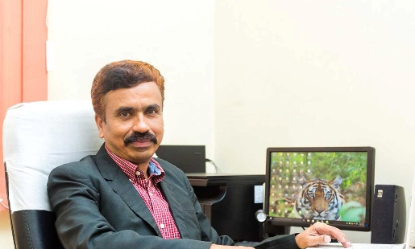 | Dr. Swamy D R  B.E, M.E, Ph.D.  Professor  JSS Academy of Technical Education Bangalore  Email ID: drswamydr@gmail.com

Dr. Swamy D R, Professor of Industrial Engineering and Management, has 30 years of experience in teaching, Research & Administration at various level with JSS Mahavidyapeetha.
- Earned his Ph.D. in 2009 through Visveswaraya Technological University, Belagavi, Karnataka, India
- He is a NBA chief coordinator- college level and instrumental in driving institution towards accreditation and ranking.
- Implemented six sponsored project supported by Dept. of Science & Technology (DST) Govt. of India & AICTE with an approximate grant of Rs.2.5 Crores and also instrumental in implementing three training programs with the support of DST, Govt. of India. Currently, he is the Principal Investigator for the project titled “Evaluation of Impact of DST FIST Program-Southern Region” funded by DST.
- Was a part of team in establishment of advance Jewellry design & training center-A center of excellence started with the support of Dept. of Industry & Commerce Govt. of Karnataka under ASIDE scheme with an investment of 4 Crores in association with Dassault systemes France & Govt. of France.
- Has received the Best Faculty award (2014-2015) from M/s Cognizant Technology Solutions and “Certificate of Excellence from Institute of Industrial Engineers during 2015.
- Was a member of Technical Advisory Committee of Karnataka Pollution Control Board 2011-2013 and was involved in the appraisal of various proposal submitted by the Industries and also member of seven professional bodies.
- At university level, actively participated in the Board of studies (Currently member of BOS, VTU Belgaum for the year 2019-2022), Board of examiner and Deputy Chief Coordinator (evaluation).
- Organized Industry Connect 2018 during December 2018, where 13 industry signed MoU with the institution to accelerate the industry based research and has also implemented consultancies with more than 15 industries in the field of Industrial Safety.
- Conducted and attended good number of workshops and National & International conferences.
- Conducted safety audits for more than 10 industries and was part in preparation of on-site emergency plan.
- Published several research papers on status of safety climate in Major Hazardous Industries.
At present, he has secured 45 research articles published in various renowned journals

EVENT:
The Webinar was held on 28th August 2021, 10am to 12.30pm in ECE Seminar Hall, Old Building, KSIT. Dr.Swamy DR, Professor, Department of IEM,JSS Academy of Technical Education, Bangalore was the resource person.Dr Surekha, Professor, Dept. of ECE started the event by welcoming the Dignitaries and Participants.
Dr.Dilip Kumar K, Principal of KSIT, welcomed the Guest Speaker with Bouquet.
Dr.KVA Balaji, CEO, K.S.Group of Institutions then gave a brief introduction about the topic and welcomed the Chief guest and his team.
He also extended warm welcome to the HoDs, and Participants.
Dr.Surekha Borra, Professor, Dept. of ECE, gave a brief introduction about the speaker and had handed over the session to Speaker.
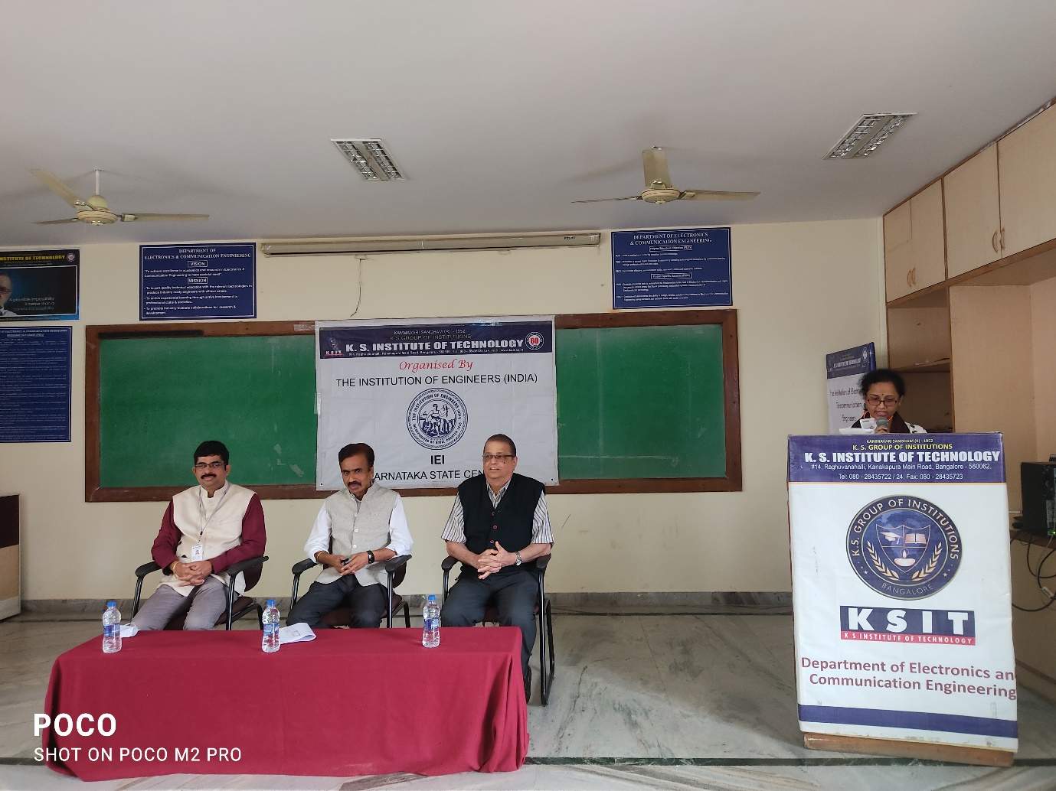
Dr.Surekha Borra Welcoming the Dignitaries and Participants
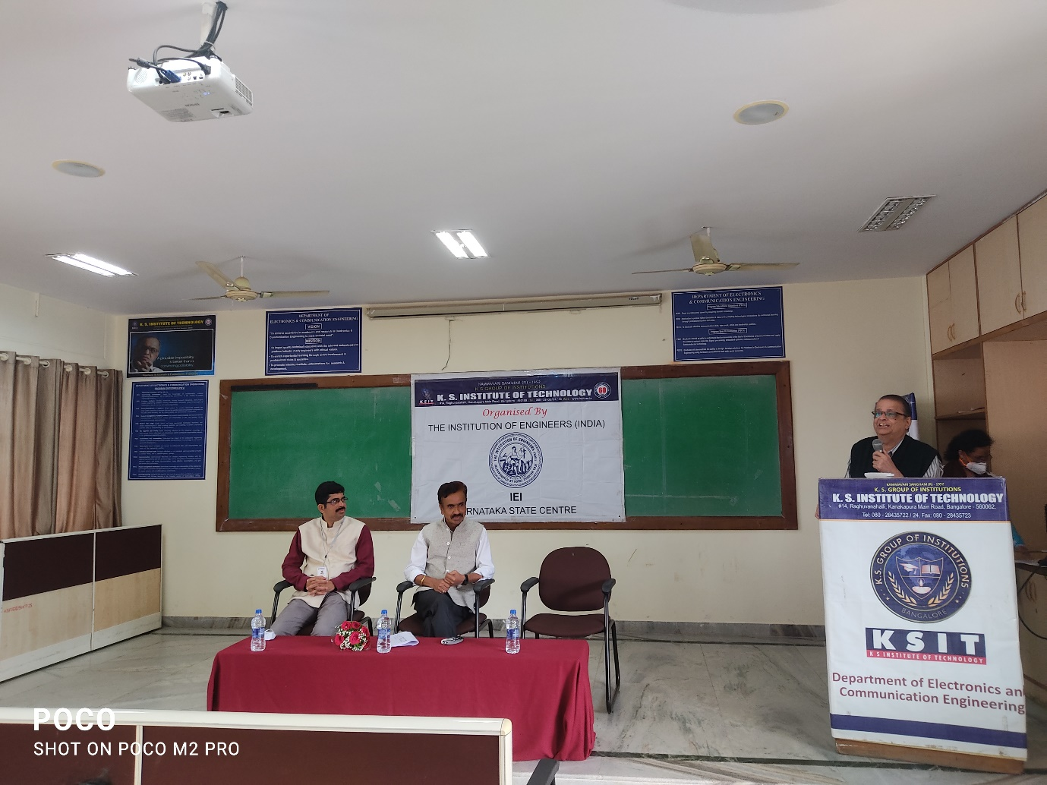
Dr.KVA Balaji, briefing the objectives of the Talk

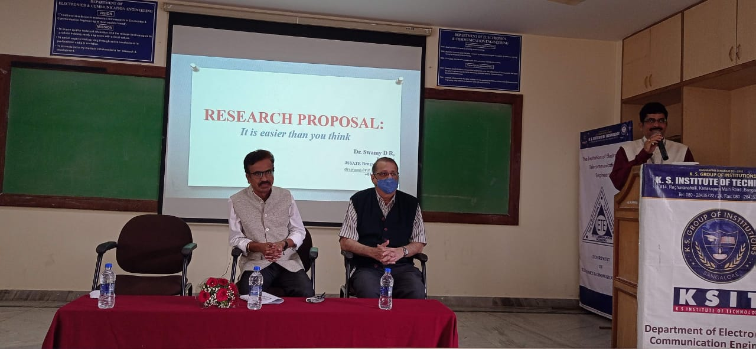
Dr.Dilip Kumar K, explaining the role of PhD holders in Research and Development
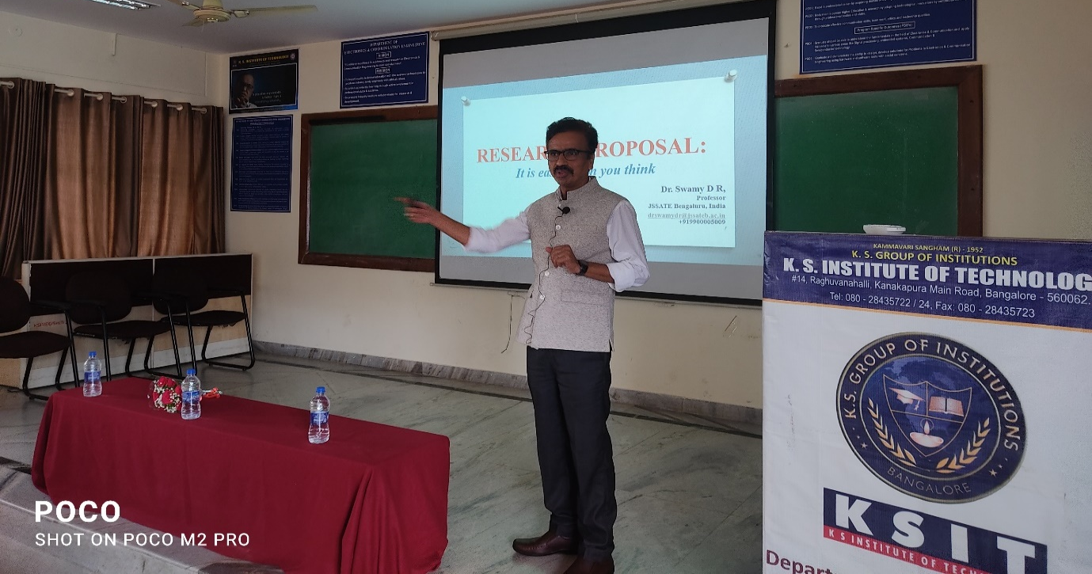
Dr.Swamy DR, Guest Speaker giving talk on Writing research Proposals for funding

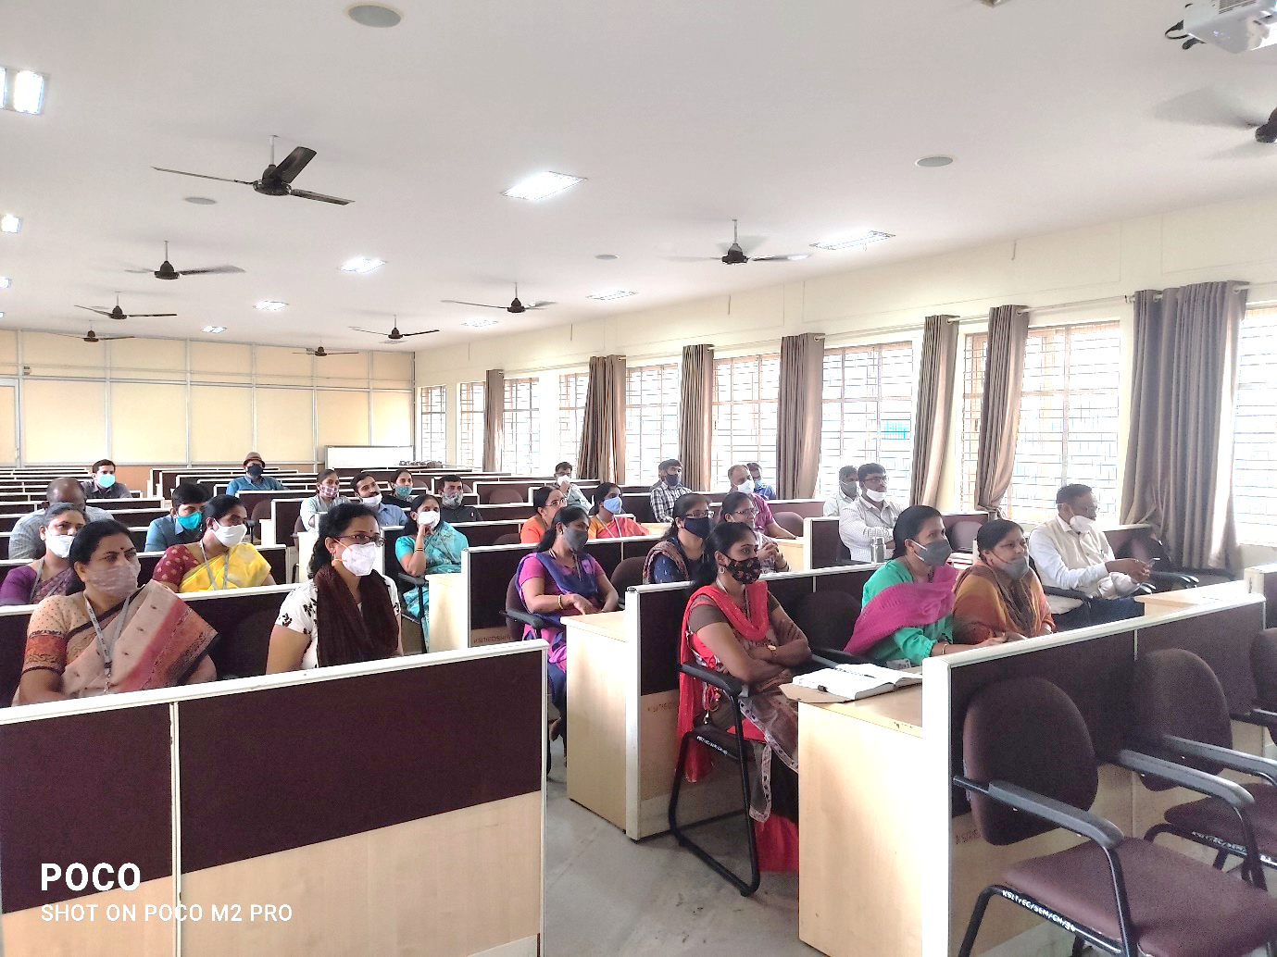
Participants listening to the talk
Program Outcome
Faculties got opportunity to understand the criteria, elements, challenges, and issues related to writing research proposals for funding.
POs Mapping with Rank
Guest Lecturer on | PO1 | PO2 | PO3 | PO4 | PO5 | PO6 | PO7 | PO8 | P09 | PO10 | PO11 | PO12
Writing Research Proposals for Funding | - | - | - | - | - | 1 | 1 | 1 | 2 | 2 | 2 | -

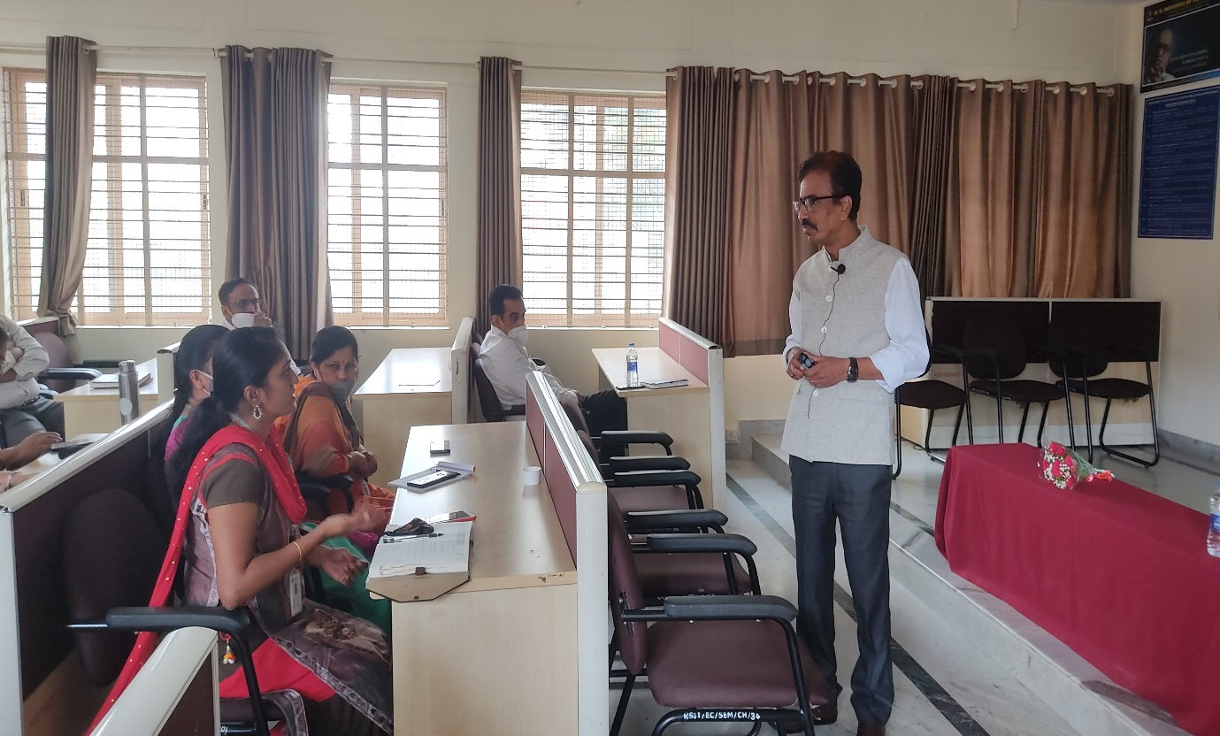
Dr.Swamy answering the queries of Participants
The topics covered are:
- What is research
- What is research proposal
- How to write research proposal
- Components/elements of research proposal
- Guidelines on writing a research proposal
- List of funding Agencies
- Common Mistakes in Proposal Writing
- The Proposal Cycle
Overall the complete session was very informative which helped everyone imbibe the knowledge about the importance and benefits of writing research proposals for funding,and the challenges involved in it.Finally, feedback was collected from all the participants via google form.
A good number (37) faculty attended the lecture. The webinar ended at 12.30 PM., and everyone signed out with positive feedback.
Outcomes of the event:
- Faculty understoodwhy they need to write a research proposal.
- Faculty understood the criteria and elements of research proposal.
- Faculty got to know the key issues and challenges involved in writing proposals.

IE(I)Coordinators HOD Principal

Dr. Surekha B Dr.PN.Sudha Dr.Dilip Kumar K
Mr.Praveen A

