
KAMMAVARI SANGHAM (R) - 1952
K.S. GROUP OF INSTITUTIONS
K.S.INSTITUTE OF TECHNOLOGY
Affiliated to VTU, Belagavi& Approved by AICTE, New Delhi, Accredited by NBA and NAAC
#14, Raghuvanahalli, Kanakapura Road, Bengaluru- 560 109
Tel : 080 28435722 / 24, Fax : 080 28435723
E-mail :principal.ksit@gmail.com / principal@ksit.edu.in/ Website : www.ksit.edu.in

A REPORT ON ONE DAY INDUSTRIAL VISIT
Place of Visit: KPCL Solar photo voltaic plant,Shivanasamudram, Malavalli
Date of Visit: 16th December 2022

Department Electronics and communication under IETE student’s forum, IEEE organized one day industrial visit for 7thSemester ECE studentsalong with faculty members to “solar photo voltaic plant”,Shivanasamudram, Malavalli on 16/12/2022 permitted by Karnataka Power Corporation Ltd.
There are total 67 students and five staff members were present during industrial visit
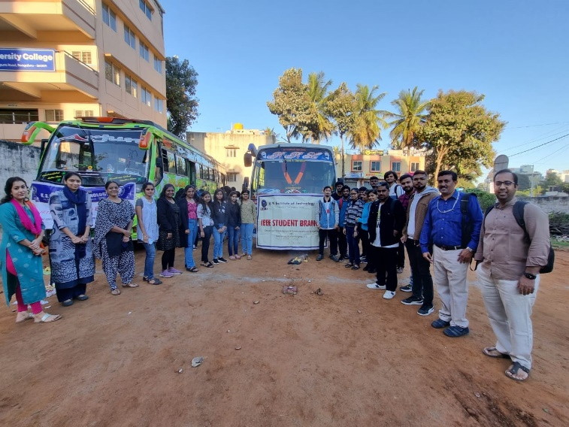

The historic site of Shivanasamudra, which has Asia’s first hydroelectric station, is set to become a hub of solar power as Karnataka Power Corporation Ltd. (KPCL) is in the process of commissioning a 10 MW grid-connected solar power plant.

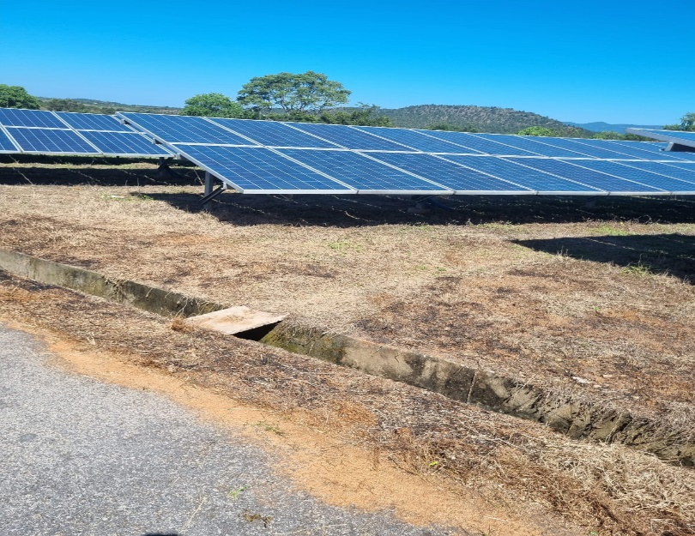
Students were given information about the technical aspects of solar power generation and supply. This particular solar power plant supplies power to half the Mysore, Kollegal, and other two Taluks. One panel consists of 72 cells with internal series and parallel connections. The structures are earthed. The installed solar PV power plant at the Shivanasamudra site would use approximately 50 acres of land. The installed solar photovoltaic power plant will be having a rating of 10MW and would be connected to the grid. There are two plants Plant A which produces 5MW and plant B which produces 3MW of power.
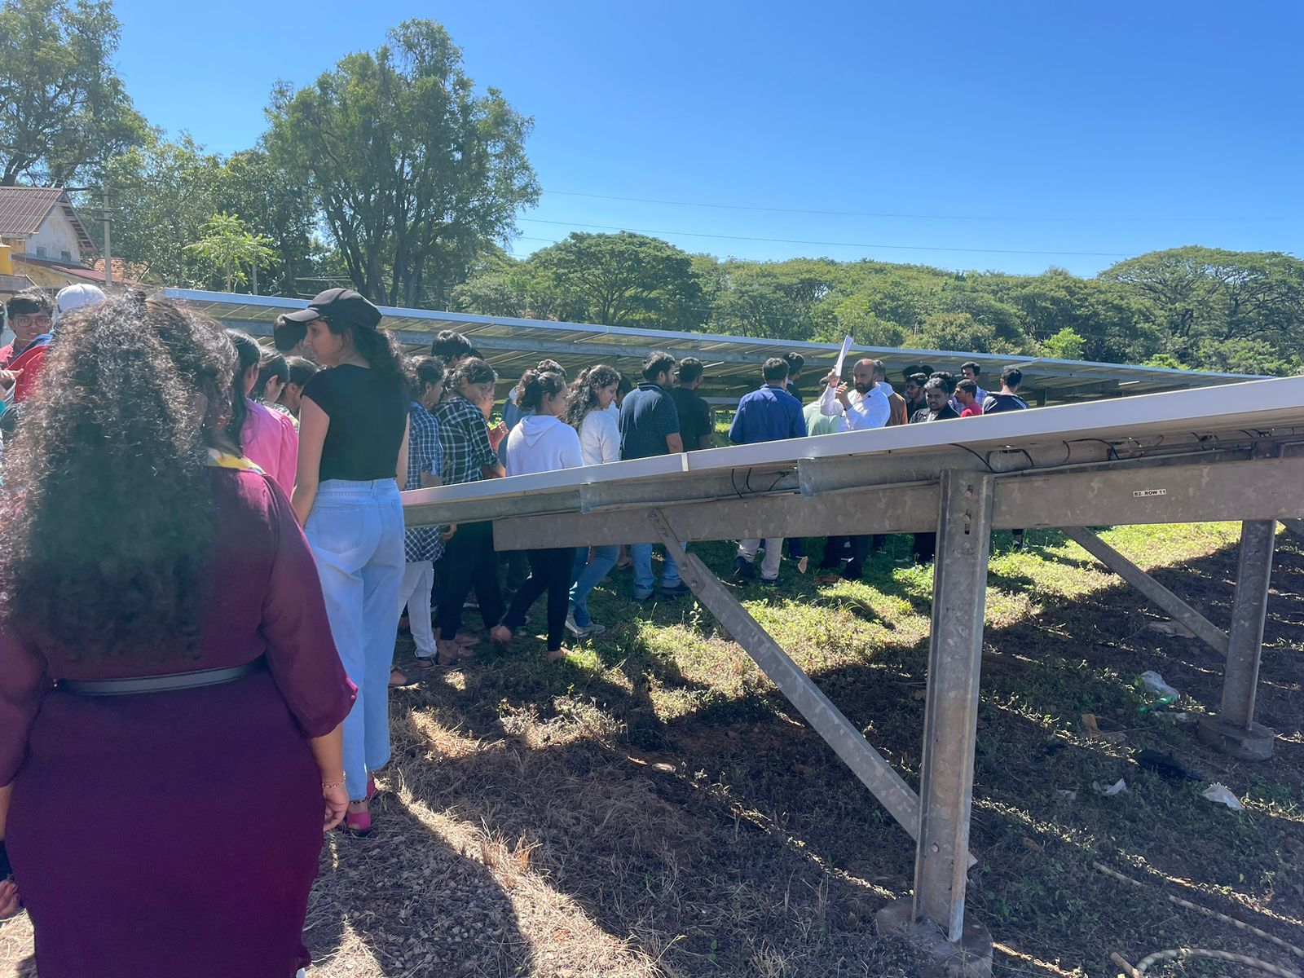

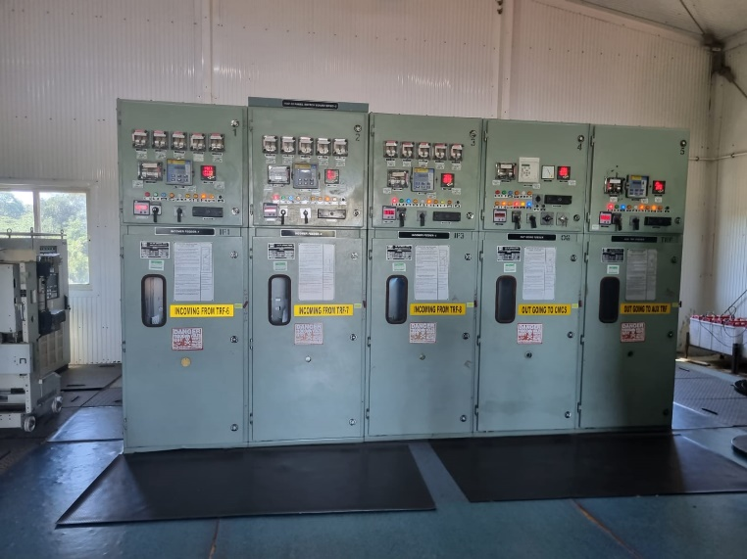
Inverter room
Outcomes of the visit:
- learning about use of renewable energy sources
- Gaining the knowledge about structure of solar cells
- Gaining the knowledge about practical design aspect of solar cells for generating 3Mega watts
- learning about use of solar tracking system
- Gaining knowledge about power transmission to grids
- learning about use of solar tracking system
- learning about maintenance of solar power plant
- materials used in solar panel and design of cells

We would like to thank our Management, Principal and HOD, Dept.of ECE for arranging this industrial visit which helps students to gain practical knowledge in the field of power generation using solar photovoltaic cells.

Mapping of FDP with PO’S and PSO’S

Program | PO1 | PO2 | PO3 | PO4 | PO5 | PO6 | PO7 | PO8 | PO9 | PO10 | PO11 | PO12 | PSO1
Industrial visit | - | - | - | - | 2 | - | - | - | - | 2 | - | 2 | 2

- PO5:Modern Tool Usage
- PO10: Participants can communicate effectively by gaining knowledge.
- PO12: Participants can apply the basic knowledge in lifelong learning.
- PSO1: Participants are able to understand and apply tools to various fields of power generation, Energy and Environment, hybrid grids,solar power generation and power transmission.

Industrial visit coordinators
Dr. Dinesh Kumar D S HOD ECE Principal
Mr.Satish Kumar B

