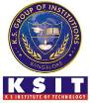
/K. S. INSTITUTE OF TECHNOLOGY
#14, Raghuvanahalli, Kanakapura Road, Bangalore-560109.
Faculty Name | Mr.Amar Sri A | 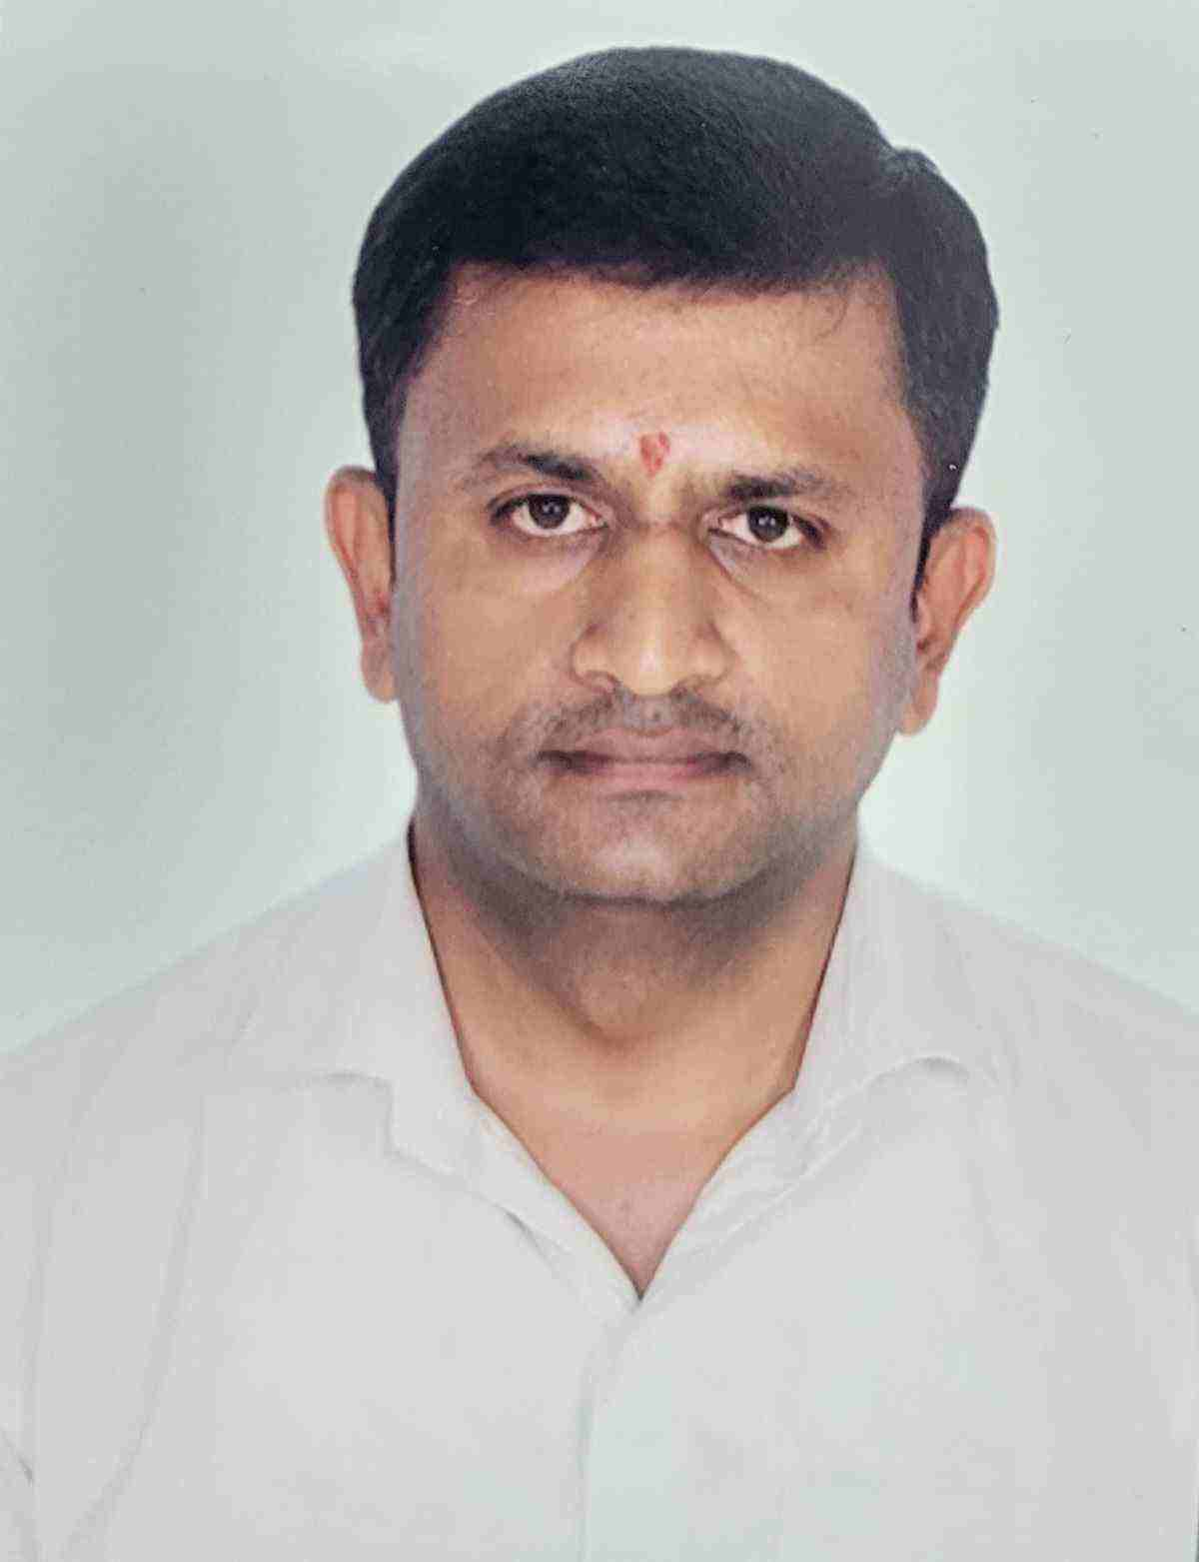
Designation | Assistant Professor
Educational Qualification | B.E, M.Tech
Experience in Years | 8
Areas of Interest | AI& ML
E-mail | amarsri@ksit.edu.in

Educational Details
Examination/  Degree | College / University | Year of  Passing
UG | JVIT, VTU | 2010
PG | SJBIT, VTU | 2014
PhD | Pursuing

Publications
  - Smart Helmet Integrated with Airbag system
  - Land Registration System Using Block chain Technology
Awards
“Recognition of QR codes with Mobile Phones” which was selected for Student Project Programme during the year 2016-2017(43rd series) by Karnataka State Council for Science and Technology (KSCST) and the project was awarded as the “Best Project of the Year”.
Professional Membership
NIL
Contact Details
Name: Prof. Amar Sri.A
Official Address: K. S. Institute of Technology, #14, Kanakapura road, Raghuvanahalli, Bengaluru-560109.
Phone Nos: 8431121013, 9448722389
Alternate Email: sriamar2016@gmail.com

